**DATA VIZUALISATION**

Q1. Create a sample table in postgres/mysql with following columns (15 Marks)

Table Name : cdac_power_bi

Column

Name - varchar

Id- integer

Age- integer

Dob – date

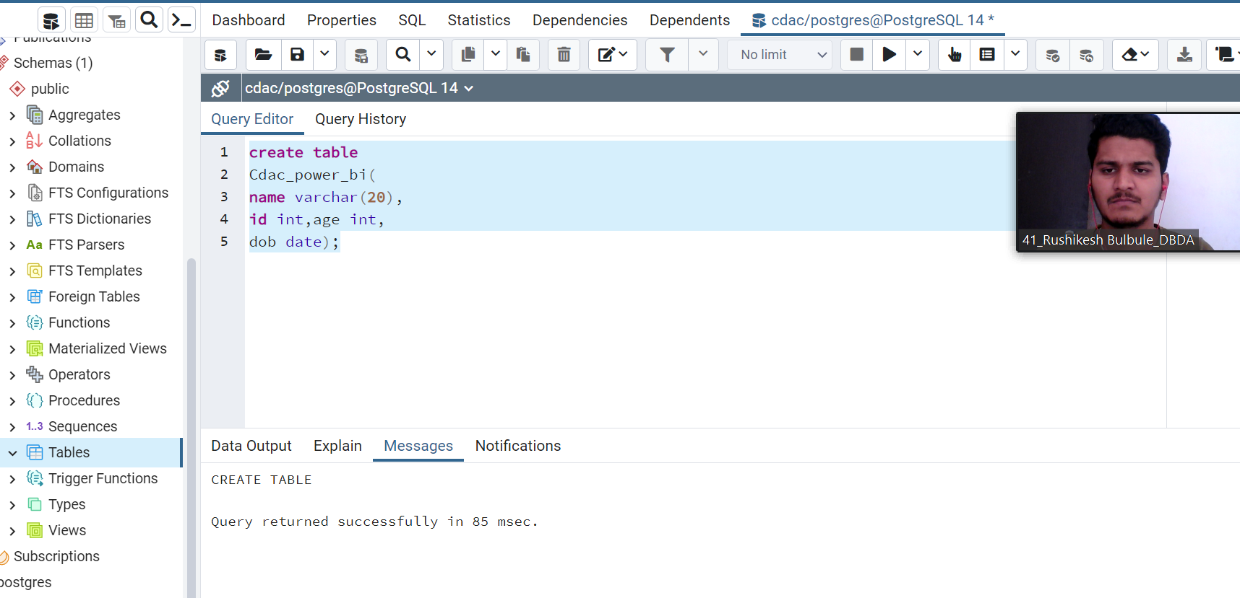

# Table is created using postgresql, now insert values into table

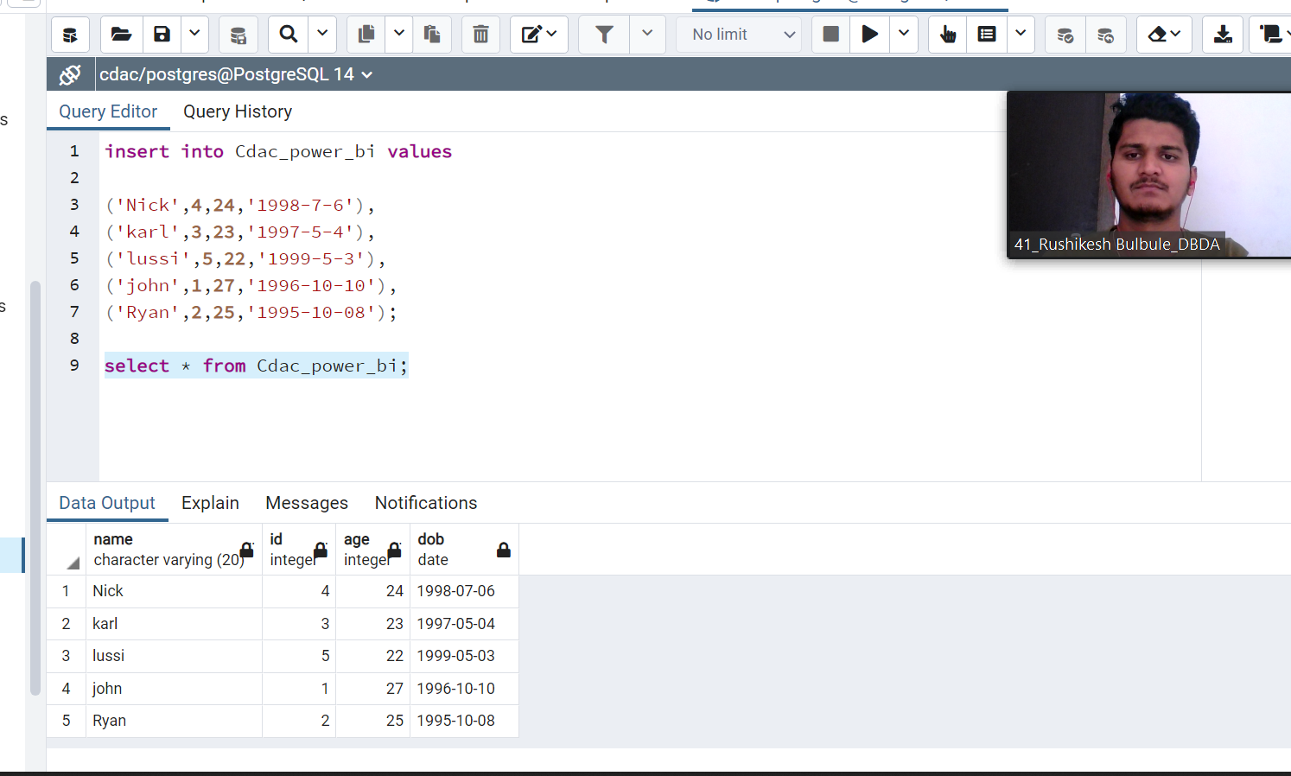

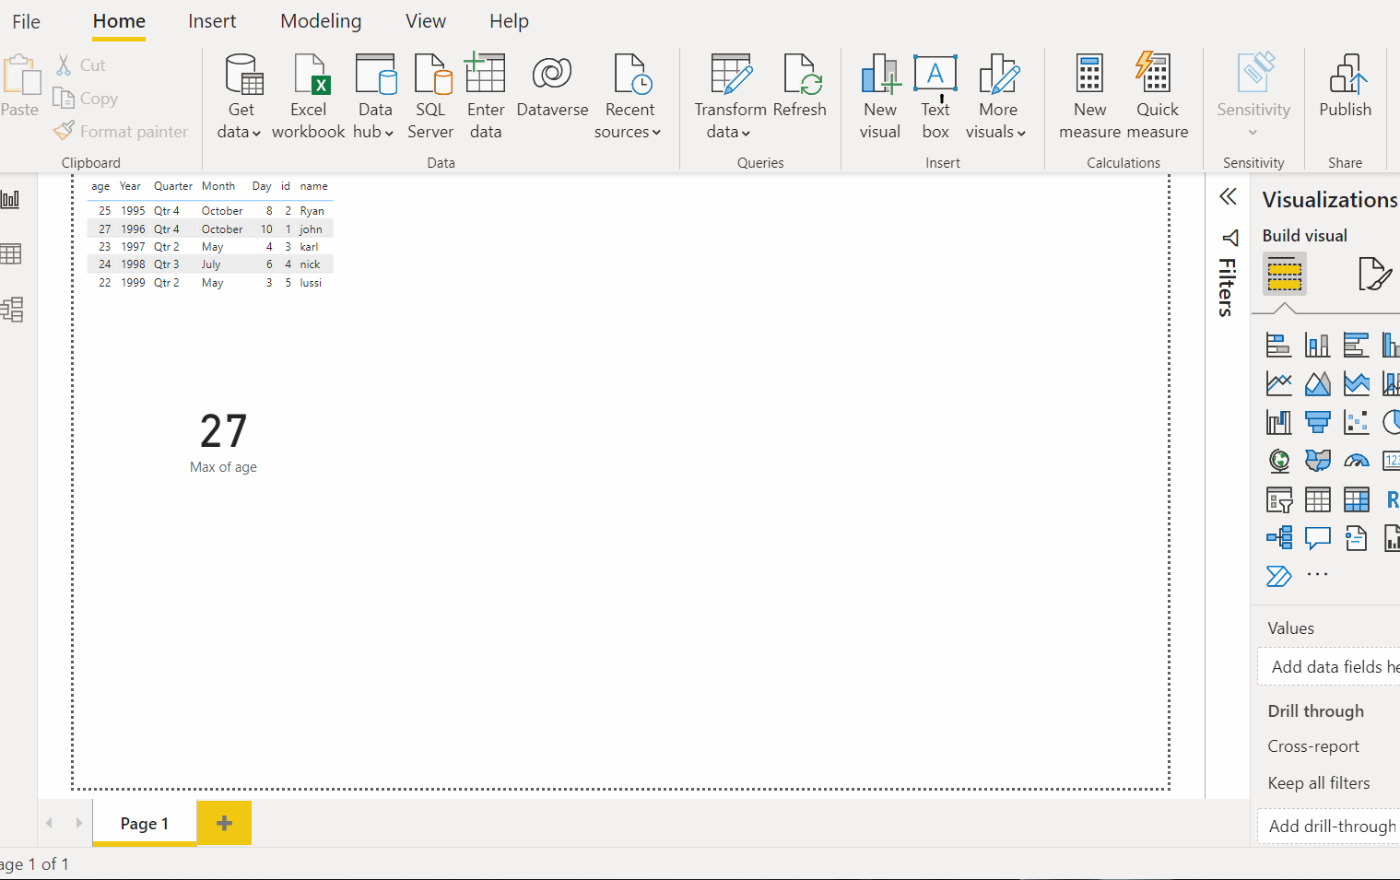

**Q2.On product_table data set do the fo llowing (25 Marks)**

